Creating Microservices for account and loan
In this hands on exercises, we will create two microservices for a bank. One microservice for handing accounts and one for handling loans.
Each microservice will be a specific independent Spring RESTful Webservice maven project having it's own pom.xml. The only difference is that, instead of having both account and loan as a single application, it is split into two different applications. These webservices will be a simple service without any backend connectivity.
Implementation:
Microservices for account:
Account.java
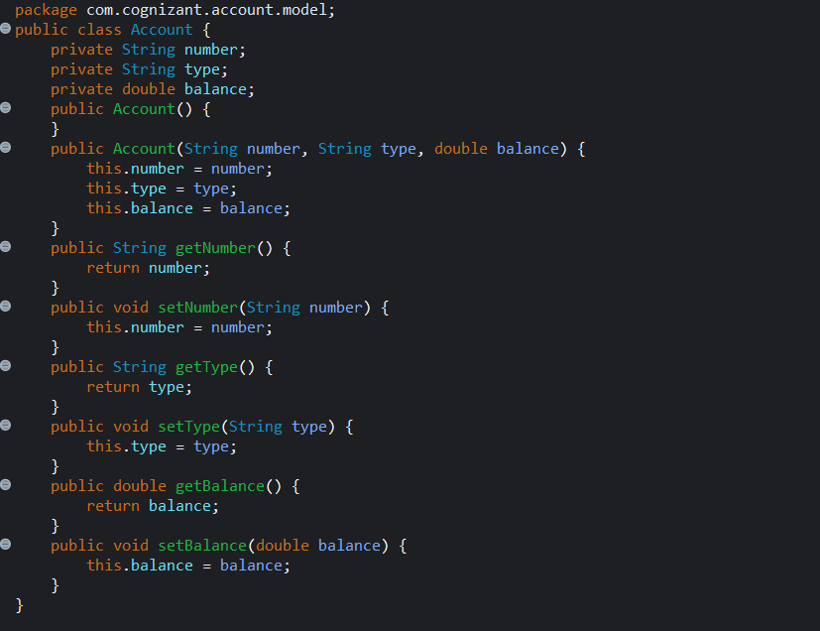

AccountController.java
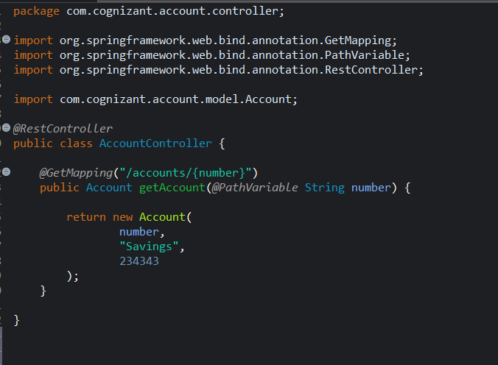

AccountApplication.java
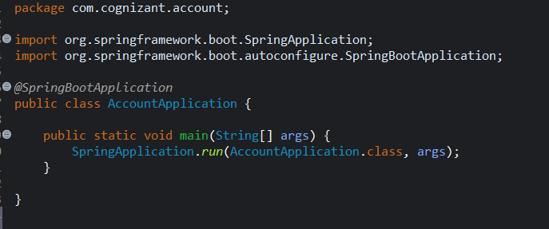

application.properties
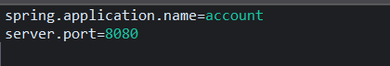
OUTPUT:
Console
Browser
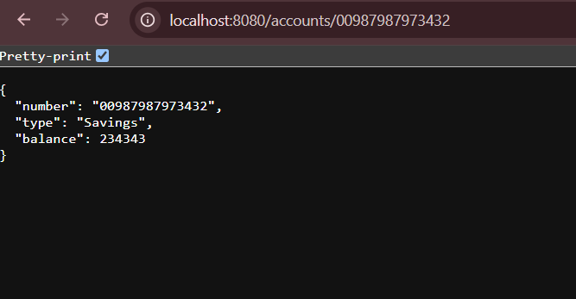

Microservices for account:
Loan.java
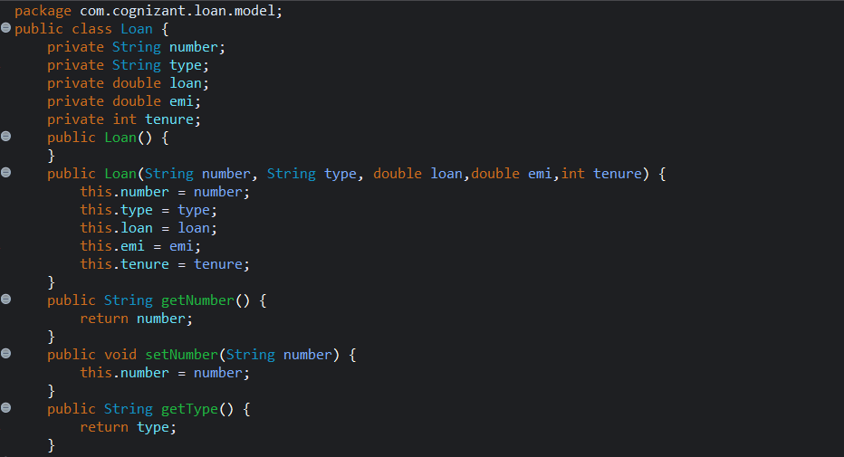
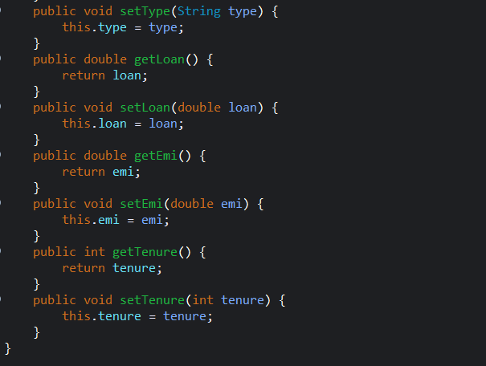

LoanController.java
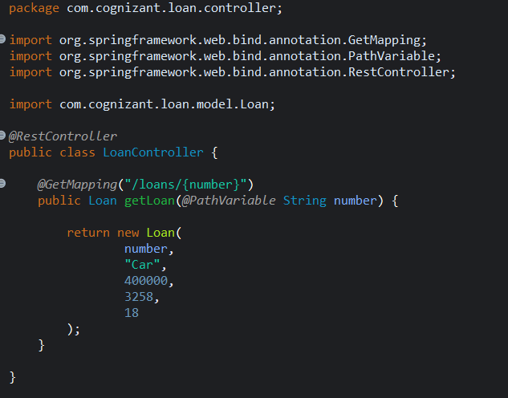

LoanApplication.java
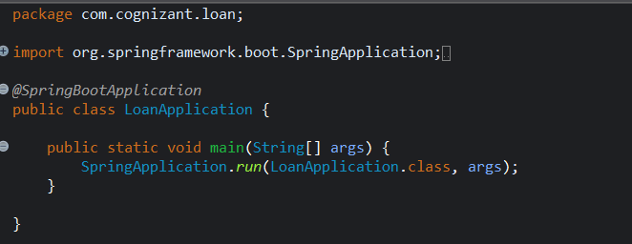
application.properties
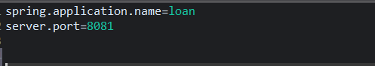
OUTPUT:
Console
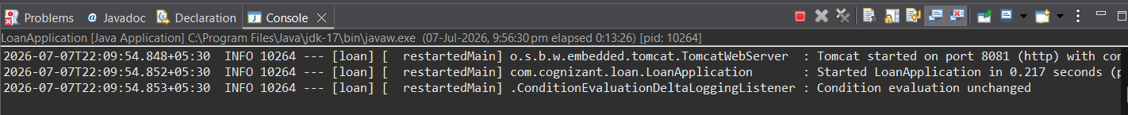
Browser
